2023
Internal Audit Department
Khalifa University of Science and Technology
March - 2023


Internal Audit Report
Review of Libraries

Table of Contents

1. Executive Summary 3
1.1 Introduction 3
1.2 Scope of Work 3
1.3 Audit Objectives 3
1.4 Audit Process 3
1.5 Summary of Audit Findings 3
2. Background 5
3. Detailed Audit Findings 6
4. Appendix 13

- Executive Summary
  - Introduction
We have completed the Review of Libraries, in line with the Approved Internal Audit Plan and Scope Letter Dated January 2023. The Internal Audit Findings / Improvement Opportunities to address associated risks / control gaps were identified and reported as part of this report.
  - Scope of Work
The Scope of Work comprised of the following areas:
- Governance and Compliance.
- Library Operations.
- Others.
- IT Infrastructure and Application.
  - Audit Objectives
The Objective of this review is to provide independent and objective assessments of KU’s business processes and systems of risk management, internal controls and governance processes. Further, assess compliance with policies/procedures and efficiency and effectiveness of operations and resource utilization.
  - Audit Process
The following are the key Audit Steps undertaken by the IA Department:
- Gain an understanding of the processes of the areas covered in the scope listed above.
- Reviewed adequacy and effectiveness of internal controls system and procedures.
- Reviewed compliance with the policies and procedures, laws and regulations.
- Agreed with process owners on action plans to improve control effectiveness / process performance.
  - Summary of Audit Findings
Controls need to be enhanced for 0% of the observations. A balance of 30% is within the moderate range and 70% is within the low range and needs to be monitored and prevented from entering the high-risk category and moderate range as applicable.

Please refer to Appendix 1 for detailed Ratings
The audit findings found during the review are summarized below. It should be noted that we have reported only on the exceptions detected during the course of our review.
- Access Rights
There is an ongoing issue with the authorization process between Alma Library Management System and KU Active Directory resulting in manual management of access rights.
- Institutional Repository
Access to AL Khazana Institutional Repository (ePrints System) is not available for KU users. An incident took place in November 2022 where data corruption occurred in the ePrints system resulting in the data backup not being restored in this System. Procedures related to administration of IR, availability and access, submission, retention and withdrawal, and updates should be captured in the Library’s Operations and Procedures Manual.

- Background
Libraries serve all faculty, staff and students at MAIN Campus and SAS Al Nakh Campus. The mission of Libraries is to support the curricular and scholarship needs of KU Community. Libraries support the teaching and learning environment by providing off and on-campus access to quality resources in print and electronic formats supporting all academic programs offered at the University. Alma System has been adopted as the Integrated Library System. Library offers various services such as Circulation, reference and research help, facilitating open access publishing, information literacy sessions including workshops on use of Library resources, document delivery etc. The annual operating expenditure budget for Libraries - 2022 was AED 14.5 Million and the actual expenditure incurred was AED 14.1 Million.
- Acquisition Services
Acquisition Services include identification, selection and purchase of Library resources for collection development purposes in support of teaching and learning of all programs and research needs of KU Community. The procurement process is routed through the ADERP system. There are currently blanket order agreements with two vendors Proquest and Gobi Solutions for providing print books. There are also agreements with vendors for electronic resources that are being renewed annually based on the needs of the University.
- Cataloging
Cataloging process involves creating bibliographic records for Library materials received, including information about the author, title, publication date, and subject matter, and organizing them into a catalog so that users can locate and access the materials they need. The cataloguing of Library resources is carried out through an open integrated Library system (ILS), Alma and the updated catalogue record is instantly available for use via Open Public Access Catalogue Primo Search. Alma allows creating new records will all required fields according to RDA (Resource Description and Access). The MARC 21 (Machine readable Cataloguing) records are supplied via the established Book Vendors and then loaded to Catalog.
- Circulation
All members of KU Community are eligible to borrow materials from the Library and are recorded in Alma. Undergraduate students can avail loan materials for two weeks for circulating materials and other KU community loans are eligible to loan Library material for a semester. All loaned materials are subject to recall by Library before due date if required.
- Public Services
Library offers services including operating the Library during operating hours, handling visitor requests, Library clearance for KU employees, workshops and literacy information sessions, events and outreach with KU community events, booking of Library rooms etc. Document delivery services are also offered and copies of journal articles and conference papers which are not available in the libraries can be obtained for KU community from British Library.
- Library Committee
Library Committee serves in advisory capacity and makes recommendation concerning the allocation of Library budget and development of the Library services and resources, reporting to the SVP Academics and Student Services.

- Detailed Audit Findings
● Medium | - Access Rights
Risk Ref : LB – 15
Observation/Process Enhancement
Alma is a cloud based Library Management System utilized to incorporate management of all resources – electronic, digital and print into one system. Alma Library Management Solution constitute of a platform for transforming the collection-focused Library into an essential, service-focused component of a research institution. Primo One Search provides one-stop searching for books and e-books, videos, articles, digital media, manage research.
- Access Rights: There is an ongoing issue with the authorization process between Alma Library Management System and KU Active Directory. As a consequence, the expected seamless integration of user access control is not functioning properly. This has led to the need for manual management of user access permissions, which is both time-consuming and error-prone. The issue requires further investigation to identify the root cause and implement a suitable solution in order to restore efficient and automated access management for all users.
Refer to below the table that illustrate the difference in access rights granted (Alma System vs. CACM Reporting).

Description | Active Users as per Alma System Records  (A) | Totals as per CACM Report  (B) | %  (A/B*100)
Faculty | 648 | 590 | 110%
Staff | 516 | 686 | 75%
Undergraduate Students | 1206 | 3079 | 39%
Graduate Students | 211 | 667 | 32%
Total | 2581 | 5022 | 51%
*Source – User Access Rights Report Alma and active records from HR /Banner CACM

- User Groups: User Groups are created by Library Team in Alma in order to classify the user under each cluster / group and define the Library privileges.
However, in 7 instances, the users were not assigned to any User Groups given their active status in Alma System, thus, indicates potential issues with regards to incorrect set up of accounts by staff without assignment to user group which included a vendor testing account. Refer to Appendix 2 - User Groups not created for further details.
Recommendation
- Coordinate with Ankabut to address the authorization matters to better manage the access to Alma System. Feasibility and timeliness to resolve access rights matter shall be explored, agreed and implemented.
- Procedure to perform periodic reviews of Alma System should be defined to ensure only authorized personnel have continued access.
Management Action Plan
Management Action Plan: Library and IT will develop a plant to integrate users from KU systems into Alma

Responsibility: IT and Systems Librarian

Timelines: December 2023

● Medium | - Acquisition Process and integration with ADERP
Risk Ref : LB-02
Observation/Process Enhancement
Acquisition Process
Acquisition Services Team is responsible for identification, selection and purchase of Library resources for collection development purposes to support teaching and learning of all programs.
During our review, we noted the following:
- No consolidated listing / control log maintained capturing all emails /web forms received as acquisition requests in 2022 and subsequent actions taken to address such requests.
- As per Section 2.14 - Acquisition Services and Collection Development Procedures, responsibilities of the Acquisition Services include to monitor and report acquisitions Turnaround time (TAT) to Management.
However, No practice is in place to establish and monitor timelines for acquisition of Library materials in line with the approved procedure.
On review of sample 5 acquisition requests (web forms) received in 2022, it was noted in 2 instances (40%) that acquisitions requested on August 2022 and November 2022 have not been received.
Further, no delivery timelines have been agreed / incorporated in the Blanket Agreement/Purchase Order for monitoring and tracking purpose.
Please Refer to Appendix 3 - Acquisition Requests for further details.
Recommendation
- Develop a consolidated log of acquisition requests received and actions taken toward processing such requests. Alternatively explore the possibility of providing ADERP PO/ Vendor Invoice reference in Alma System for tracking and monitoring of procured resources.
- Timelines of acquisition of Library materials shall be established, monitored and reported on a periodic basis.
Management Action Plan
Management Action Plan: A Log of acquisition requests will be implemented, and the timelines for acquiring Library materials will be reported periodically.

Responsibility: Collection Development Librarian

Timelines: December 2023

● Low | - Overdue Books / Items
Risk Ref : RC – 09
Observation/Process Enhancement
- As per Section 5.5 of Policy LIB 8700 (Library Circulation), “the Library may charge fines on overdue items” and as per Section 5.6 of Policy LIB 8700, “Library Management reserves the right to waive fines in exceptional circumstances”.
However, there is no process / actions taken to levy charge / penalty for overdue books (delay of days of return from the original due date). Refer to Appendix 4 - Long Overdue Items.
- As per the Public Service Procedure, overdue items are marked as lost after a specific period of time (6 months for Undergraduate Students and 12 months for Graduates, Faculty and Staff) and charged to users for replacement cost plus VAT and processing fee of AED 50 per item.
Further, overdue items are marked as lost in case the overdue books were neither returned nor renewed given that notices are sent to patrons with the notification that their accounts shall be blocked. Its worth mentioning that during the pandemic period, the process of sending overdue notices was halted (resumed in 2023).
However, it was noted that the charges on account of overdue items (marked as lost) were not made in 2022 from patrons. Further, in 17 instances, the Library accounts have not been blocked for Patrons with long overdue items.
Refer to Appendix 5 - Patrons with long overdue books without account block.
Further, Library procedure do not set limit of renewals of Library materials.
Recommendation
- Ensure compliance with policies and procedures for overdue items. However; KU Management may consider revisiting the approved policies and procedures in order to revise the clauses in case the Library Management believes that levying charges / fines may not be acceptable by KU Community / KU Management.
- Block of patron Library account in line with the approved procedure – for overdue items.
- Update the Library procedure to include limit of renewals.
- Penalties / fines waived off should be made in documented and approved format, with adequate justification.
- KU Management may consider revising the Delegation of Authority in order to specify / define the authority to waive off Library fines penalties.
Management Action Plan
Management Action Plan: All long-overdue items will be brought into policy compliance. Patrons with long-overdue items will have their records blocked. Library procedure manual will be updated to refer to number of allowed renewals. Library policy will be updated to remove fines for overdue items.

Responsibility: Systems Librarian

Timelines: December 2023

● Low | - Physical Stock Verification of Library Materials
Risk Ref : RC – 08
Observation/Process Enhancement
The Physical Stock Verification exercise involves physical count of all books and other materials in Library to ensure inventory matches the system records.
As per Public Service Procedures, an inventory of all physical items at Library branches will take place at least every two years.
- Stock Verification Plan
A physical stock verification plan outlines the frequency and scope of physical verification of Library books taking into consideration the date, location, size of collection and responsible personnel required to conduct the physical verification.
However; the stock verification plan has not been made in documented and approved format covering all the verification requirements as stated above.
- Stock Verification Report
- Although the Physical Stock Verification for SAN Campus has been performed in December 2022, the inventory report highlighting the discrepancies has not approved by the Libraries Management (i.e. Director, SVP).
The physical Verification process for MAIN Campus Library is currently under progress.
- A consolidated report highlighting the status of physical Library materials at both campus is yet to be developed.
Currently the Inventory management process as per Public Services procedure do not address the process for preparation and approval of physical verification plan / report and actions to be taken to address discrepancies (missing materials, physical items available not recorded in system) on completion of the exercise.
Recommendation
- Develop Physical Verification Plan covering the date, location and responsible personnel.
- Ensure Physical Verification results are documented and approved.
- Address discrepancies noted in physical verification and make necessary adjustments within defined timeframe and ensure procedure are updated to address such matters.
Management Action Plan
Management Action Plan: Physical inventory verification will be completed. Current inventory wwill be completed, documented, and approved. Discrepancies in the inventory will be accounted for and Alma updated.

Responsibility: Systems Librarian

Timelines: December 2023

● Low | - Electronic Resources
Risk Ref : LB– 02
Observation/Process Enhancement
- Monitoring of Usage Statistics
KU subscribes to different electronic resources amounting to approximately AED 14 million. The Usage statistics for e-resources are generated from separate vendor sites.
Review of usage statistics of electronic resources is performed on a need to know basis, without taking into consideration developing a centralized platform to monitor the usage statistics of electronic resources.
- Library Committee
As per the Acquisition Services procedure Section 5.9, Library Committee reviews the electronic resource subscriptions and provides needed usage statistics / other necessary information to make informed decisions.
As stated in the MoM, Library Committee discusses the yearly Library renewal of electronic resources. However, the usage statistics reports are not provided to Library Committee for their review. Further, MOMs of Library Committee are not signed by the Committee Members.
Recommendation
- Improve electronic resource utilization monitoring tools at a centralized platform and explore the possibility of utilizing Alma Analytics Dashboard for monitoring electronic resource usage statistics using Counter Compliant data and Alma Link Resolver (links to electronic resources from any Open URL compliant source) for vendors that are non-Counter Compliant for centralized reporting purposes.
- Define key usage statistics for e-resources management reporting and ensure adequate reporting of such statistics to Library Committee for monitoring purpose. The report may include Cost per use, Most used vendors/titles/platforms, Top requests/searches/downloads and Usage by subject area.
- Ensure MoMs of Library Committee are signed by Members.
Management Action Plan
Management Action Plan: Library will implement data collection and analysis within Alma reports, as far as possible for all compliant vendors. The data will then be used to monitor usage and create analytical reports. Library Committee minutes will be approved by all members.

Responsibility: Electronic Resources Librarian, Systems Librarian, and Library Committee Secretary

Timelines: June 2024

● Low | - Duplicate Titles
Risk Ref : LB – 01
Observation/Process Enhancement
The purpose of cataloging entails organizing Library resources for effective discovery and use in support of university, teaching and research activities.
On review of Title Overlap Analysis Report from Alma, it was noted that 2195 same/duplicate titles in physical inventory having separate MMS (Meta data management system/unique record) ID.
A cataloguing project has been initiated from April 2022 which is currently under progress to minimize duplicates and errors for physical books.
Recommendation
Review existing titles to identify whether the bibliographic records needs to be merged to update Library catalog which enables easier retrieval of information by the users.
Management Action Plan
Management Action Plan: The currently implemented project of Cataloging Services will continue, in which all records are examined to fix errors.

Responsibility: Cataloging Librarian and Cataloging Officer

Timelines: January 2025

● Medium | - Institutional Repository
Risk Ref : LB-04
Observation/Process Enhancement
Institutional repository (IR) hosts selected archival materials generated by KU that documents the history and intellectual life of KU to support learning, teaching and research. It contains digital collections created from the Library archival holdings including Journal articles (peer-reviewed), Theses and dissertations, Technical reports and other materials at the discretion of the repository administrators, the Library Committee, or academic leadership.
Access to AL Khazana Institutional Repository (ePrints System) is not available for KU users. An incident took place in November 2022 where data corruption occurred in the ePrints system resulting in the data backup not being restored in this System. A new Institutional Repository System replacing the old system is in the pipeline for implementation.
As per Section 5.7 of LIB 8550 Policy (Institutional Repository), Procedures related to administration of IR, availability and access, submission, retention and withdrawal, and updates should be captured in the Library’s Operations and Procedures Manual.
However, no formal procedure has been developed to address the IR Activities.
Recommendation
- Restore data backup of Institutional Repository and ensure adequate migration to the new System.
- Procedures should be revised to address the key activities of IR such as, administration of IR availability, access, submission, retention and updates to IR, thus, alignment between the approved procedures and key IR activities shall be ensured.
Management Action Plan
Management Action Plan: Library procedure manual will be updated to included all agreed activities.

Responsibility: Systems Librarian

Timelines: January 2024

● Low | - Alumni Access
Risk Ref : LB – 01
Observation/Process Enhancement
As per Section 5.3 of LIB 8500 Policy (Access to University Libraries and Learning Centers), “Borrowing privileges are limited to KU Faculty, Students, Staff, Researchers and Members of the Alumni Association”.
However; there are no Library membership privileges/access have been granted to KU Alumni.
Recommendation
Ensure compliance with LIB 8500. KU Alumni should be granted access to KU Libraries to avail Library membership privileges, in liaison with Student Services/Alumni Department.
Management Action Plan
Management Action Plan:
Career Services and IT team working to ensure the successful implementation of the following initiatives:
- Creating email accounts for KU alumni (currently in the testing phase)
- Providing alumni with access to E-Services, Library, and Coursera
Responsibility: Career Services and IT
Timelines: Dec 2023
● Low | - Service Evaluation Surveys
Risk Ref : LB – 10, LB-08
Observation/Process Enhancement
Evaluation surveys and feedback forms helps to evaluate the effectiveness and impact of Library programs and services and determine whether they are meeting the needs of KU Community and identify areas of improvement.
- Public Computers at Library
Library Services Evaluation Survey – 2022 conducted through Institutional Research and Planning indicated that only 17.22 % (951 out of 5524) has provided feedback.
Survey respondents have emphasized on the necessity of fixing the software / hardware computer issues (lag and slow functioning). Reliable and efficient technological infrastructure is required to ensure adequate maintenance of Library facilities.
To further elaborate on this, the existing computers utilized by Library are aged between 7-10 years (almost outdated), of which, 39 computers in MAIN Campus are not fully functional due to technical issues (refer to below table for details):
Campus | Purchase Date /Year | Ageing (Years) | Quantity of Computers
MAIN | 2016 | 7 | 226
SAN | 2015/2013 | 8-10 | 42
Total |  |  | 268
It’s worthwhile to mention that the number of user sessions accessed via Laptop / PCs was (95.2%) - higher than Smartphones, Please refer to Appendix 6 - User Sessions by devices for further details.
- Feedback on Library Workshops and Information Literacy Sessions
On review of sample of 2 out of 4 (50%) workshops and 3 out of 4 (75%) information literacy sessions conducted in 2022, it was noted the survey result were not available. Please refer to Appendix 7- Workshops and IL sessions.
Recommendation
- Explore the possibility of upgrading the quality of public service computers. A study may be required (in coordination with Ankabut) to define the expected proportion of upgrades / new in-house computers required taking into consideration the use of laptops brought by patrons at Library premises.
- Improve feedback response received from patrons by encouraging feedback, creating user awareness and providing incentives.
- Ensure adequate maintenance of survey results and follow up for future improvement.
Management Action Plan
Management Action Plan: Library and IT will work out a plan to decide on a reseasonable number of operable computers, either new or repurposed, given the changing landscape of computer usage. Then a budget plan will be made to meet these needs. Surveys will continue to be mailed to attendees at the completion of each workshop for feedback and information.

Responsibility: Library and IT

Timelines: June 2024

● Low | - Library Portal / Webpage
Risk Ref : LB – 01
Observation/Process Enhancement
Libguides System is being utilized as the Content Management System by Library for the webpages.
Our review of Library webpage showed that the timings of operating hours in certain webpages are not consistent with the actual timing.
Further, some of the information are not updated such as; closed Library locations, resigned employees, incorrect telephone numbers and research guide links being referred to old PI sites/broken links.
Refer Appendix 8 - Library Portal/Webpage.
Recommendation
Ensure timely update of Library webpages.
Management Action Plan
Management Action Plan: Library will review all library pages and update errors.

Responsibility: Systems Librarian

Timelines: December 2023

Appendix

Appendix 1
Findings Rating
The audit findings have been grouped together in a logical manner to appropriately convey the risk and impact. The audit findings have been categorized based on their criticality rating as High, Medium and Low. The definitions of the findings criticality / distribution are provided in the table below
 | Finding Rating | Definition | Number of Findings | Total
● | High | Finding is serious and deserves immediate attention by the Process Manager. The finding is reported to the Audit Committee quarterly. | 0 | 10
● | Medium | Finding impacts the accomplishment of the Process objectives. Corrective action is required by management. If not resolved, the finding could result in inefficient use of entity resources and or potentially disrupt business processes. | 3
● | Low | Finding to be reported to Management but is of a minor risk to the entity. Findings will not be reported to the Audit Committee unless the finding remains open after the follow up audit. | 7

Appendix 2 - User Groups not created
User ID | Last Activity Date | Role Expiry Date | Remarks
1471455850007456 | 2-Feb-2023 | 2-Feb-2024 | -
1470271670007456 | - | 2-Feb-2024 | -
1460833770007456 | 16-Jan-2023 | 16-Jan-2024 | -
1442666310007456 | 9-Jan-2023 | 9-Jan-2024 | -
1334641020007456 | - | 21-Nov-2023 | -
1322600980007456 | - | 9-Nov-2023 | -
294982470007456 | - | - | Vendor testing account

Appendix 3 – Acquisition Requests
Title | Request Submission Date | Received | Remarks
Data Driven Fluid Mechanics- Miguel A | 9-Nov-2022 | No | The publication was due in Dec 2022. This was preorder request, not yet published. Print copy will take time
Ballad of Songbirds and Snakes Hunger Games | 22-Aug-2022 | No | The item is preparing to ship

Appendix 4 - Long Overdue Items
Patron Group | Ageing (Days) | Count of Books | %
Faculty | 365-730 | 51 | 49%
Graduate | 365-730 | 16 | 15%
Staff | 365-730 | 15 | 14%
Undergraduate | 365-730 | 14 | 13%
 | 180-365 | 9 | 9%
Total |  | 105 | 100
*Source – Alma Report

Appendix 5 - Patrons with long overdue books without account block
Patron Group | User ID | No of books | Remarks
Faculty | 757985060007456 | 2 | Accounts are not blocked in system for overdue books
Faculty | 758049880007456 | 1 | Accounts are not blocked in system for overdue books
Faculty | 758080750007456 | 16 | Accounts are not blocked in system for overdue books
Faculty | 758081580007456 | 9 | Accounts are not blocked in system for overdue books
Faculty | 758090040007456 | 2 | Accounts are not blocked in system for overdue books
Faculty | 758099570007456 | 1 | Accounts are not blocked in system for overdue books
Faculty | 758131340007456 | 13 | Accounts are not blocked in system for overdue books
Faculty | 758222170007456 | 1 | Accounts are not blocked in system for overdue books
Faculty | 758225860007456 | 4 | Accounts are not blocked in system for overdue books
Staff | 758000590007456 | 2 | Accounts are not blocked in system for overdue books
Undergraduate | 758009570007456 | 1 | Accounts are not blocked in system for overdue books
Undergraduate | 758052180007456 | 1 | Accounts are not blocked in system for overdue books
Undergraduate | 758070700007456 | 1 | Accounts are not blocked in system for overdue books
Undergraduate | 758086630007456 | 1 | Accounts are not blocked in system for overdue books
Undergraduate | 758163100007456 | 1 | Accounts are not blocked in system for overdue books
Undergraduate | 758173700007456 | 1 | Accounts are not blocked in system for overdue books
Undergraduate | 758195930007456 | 1 | Accounts are not blocked in system for overdue books

Appendix 6 – User sessions by device
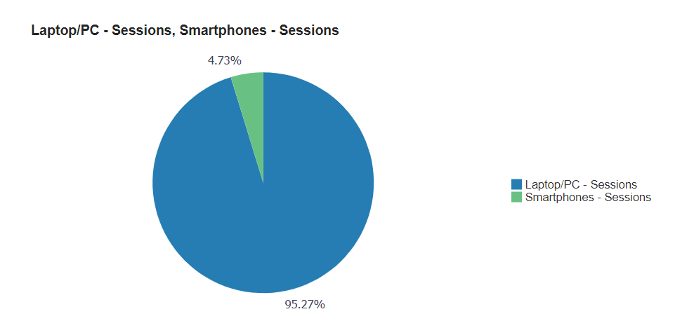
*Source Primo Analytics

Appendix 7 - Workshops and IL sessions
Date | Session Type | Title | No of attendees | No. of response | %
9-Feb-2022 | Workshop | Pub Med | 25 | 0 | 0%
16-Nov-2022 | Workshop | Embassy and Cochrane Library | 4 | 0 | 0%
14-Sep-2022 | Workshop | E-resources & Search Techniques | 27 | 6 | 22%
14-Nov-2022 | Workshop | Standards & Patents | 9 | 2 | 22%
12-Oct-2022 | Information Literacy Class | MEEN Literature and Patent Review for Senior design class | 18 | 0 | 0%
20-Oct-2022 | Information Literacy Class | RefWorks and Resources Session for Technical and Scientific Writing - 10955 - COMM 601 - 01 - Dr. Aisha AlSuwaidi's Class | 10 | 0 | 0%
19-Jan-2022 | Information Literacy Class | Adjuncts Library basics | 2 | 0 | 0%
9-Nov-2022 | Information Literacy Class | Library IL continuous activity - searching and borrowing books - Eng 102 sec 01 - Matthew Andrew's Class | 21 | 11 | 52%

Appendix 8 – Library Portal/Webpage
Library hours and location of Library needs to be updated and reference to removed location (Arzanah)

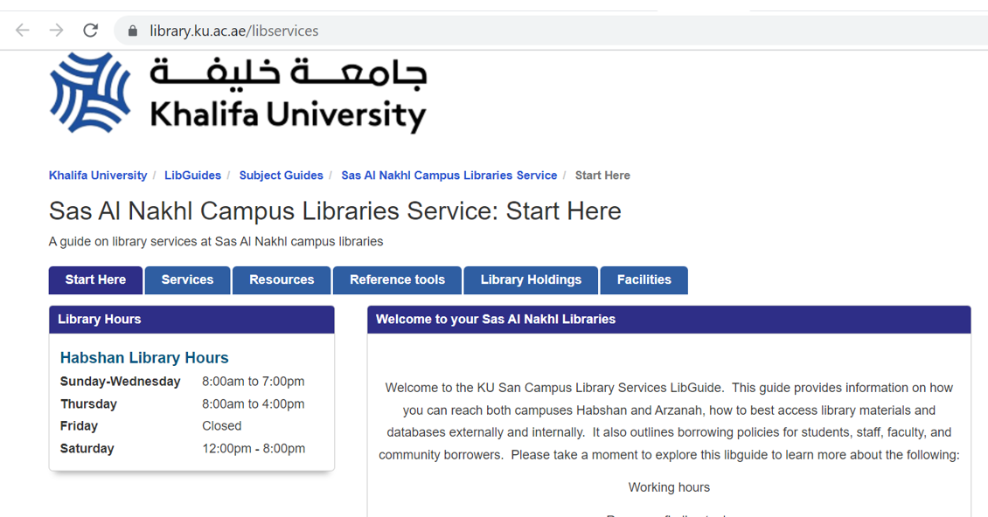

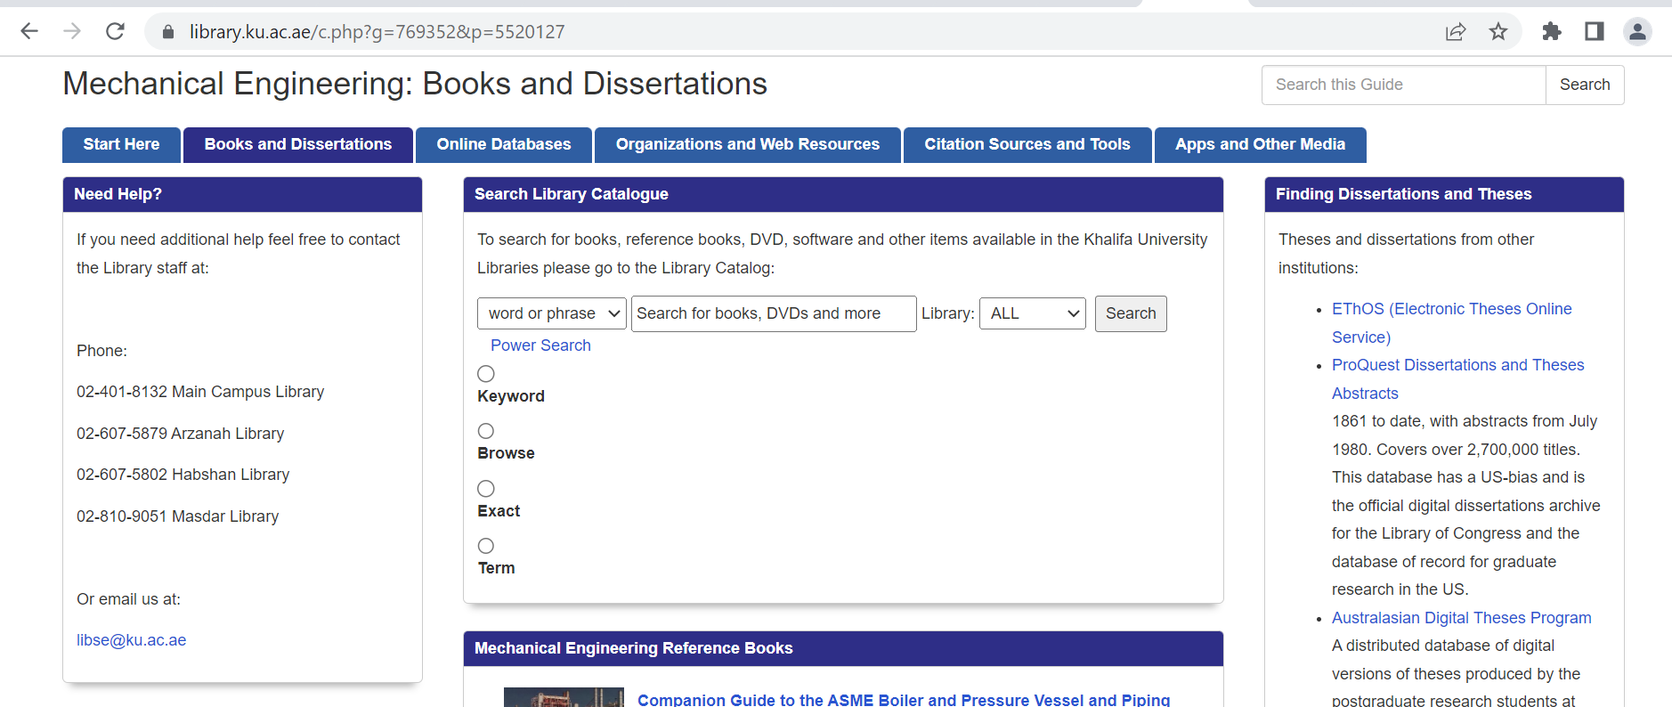

Referance to resigned employees in the website
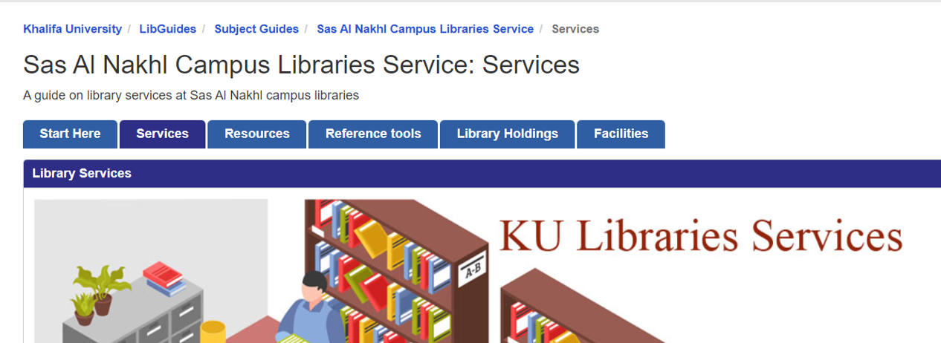
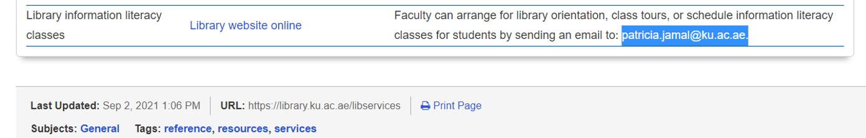

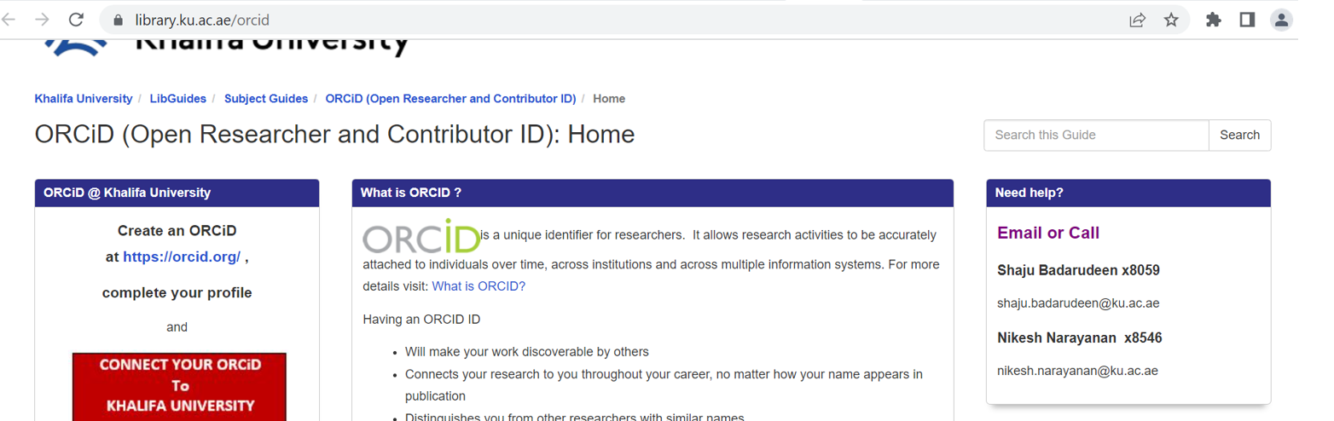

Research Guides links needs to be updated
